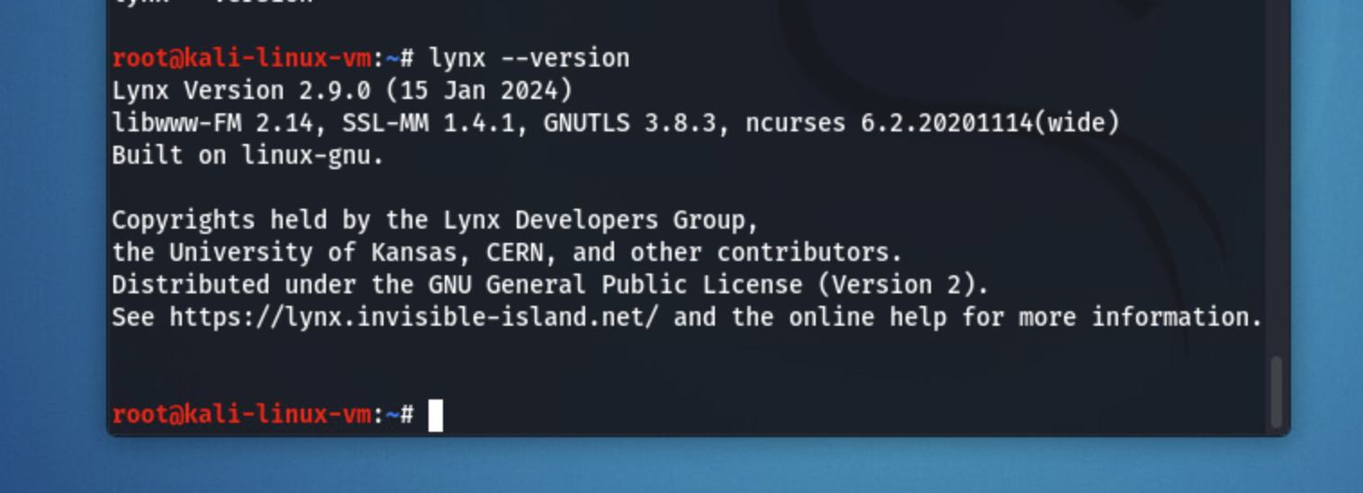

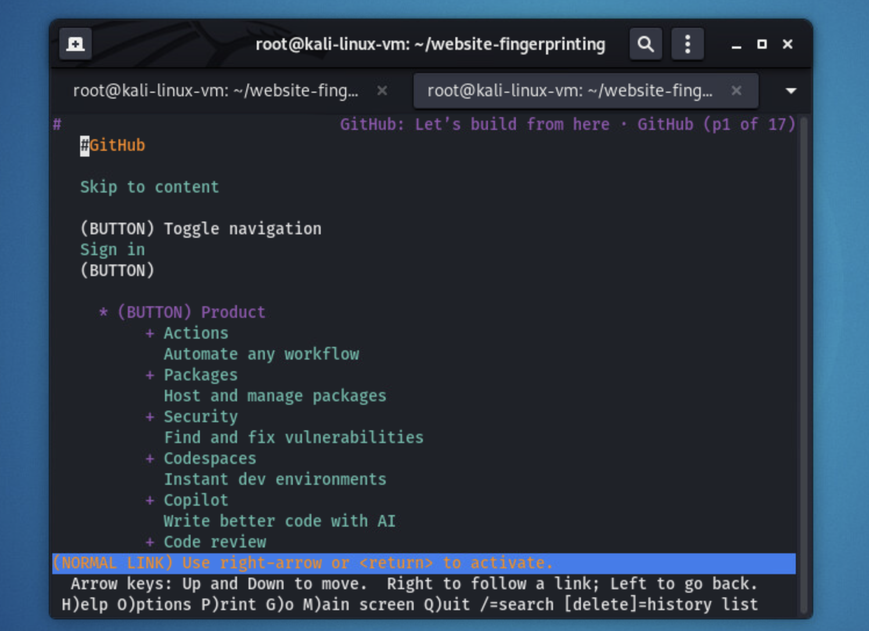

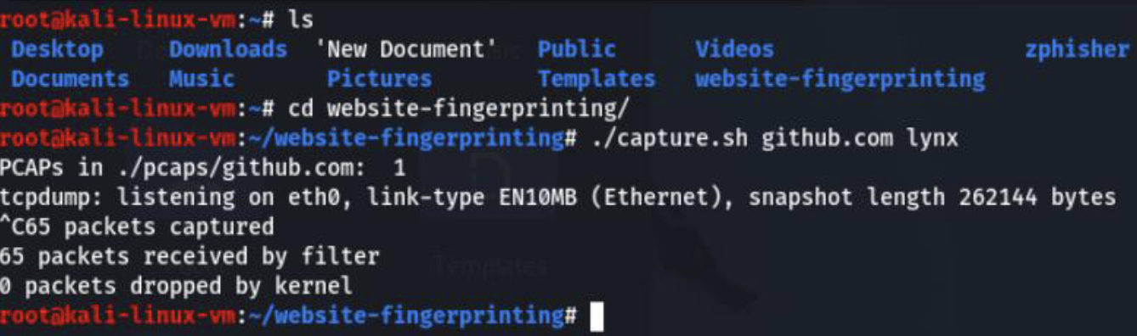

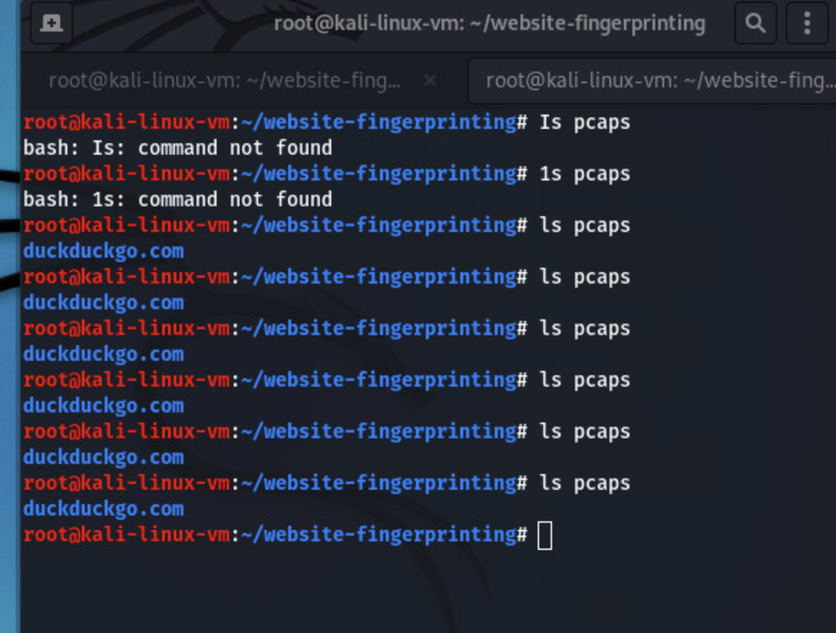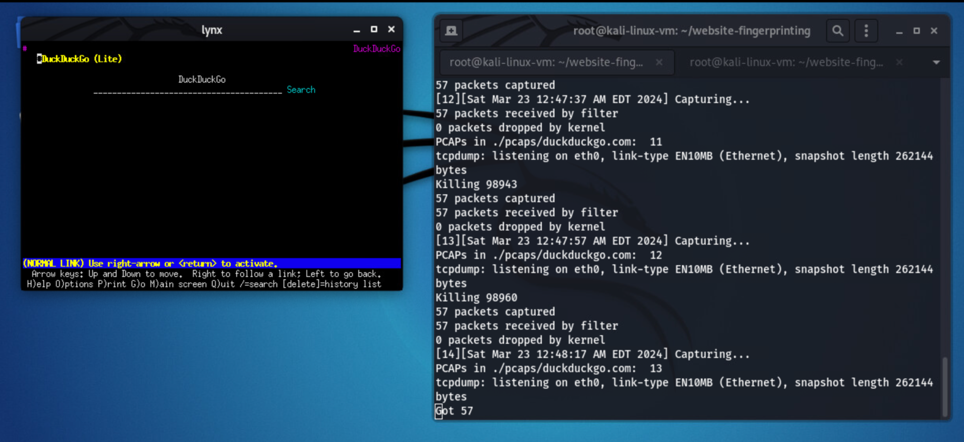

7. It means it can reach 90.9 accuracy out of the websites in the program

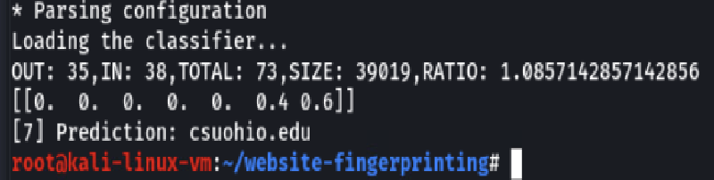

9. Yes, a classifier can still predict correctly even if used one month later, but its accuracy may vary depending on the changes in the website content. Here's why:

A classifier is a machine learning model that is trained to predict the categories of data. Once a classifier is trained on a certain set of data, it can make predictions based on that training. However, if the nature of the data changes significantly over time, the classifier's predictions may become less accurate.

For example, if a classifier is trained to categorize news articles into different topics, and the topics of the articles on the website change significantly over a month, the classifier may not be as accurate in its predictions. This is because the classifier was trained on the old data, and the new data may have different features that the classifier is not familiar with.